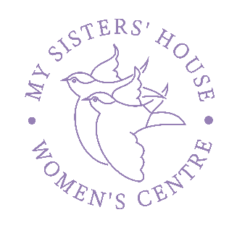
My Sisters’ House CIO is a grassroots organisation set up by a group of local women, and governed by our Board of Trustees. We opened the first drop-in in May 2015. We are the only women’s centre in West Sussex. Embedded in the Bognor Regis community, and now with a hub in Chichester, we work across the coastal area of West Sussex.
Our Patron is Dame Julie Walters DBE.
Our beneficiaries are women and girls who face multiple and complex issues and trauma, including violence and abuse, poverty, unemployment, low self-esteem, and poor mental and physical health.
We have a unique reach within our community and fill essential gaps in statutory provision. As the ‘net beneath the net,’ we are an independent, frontline service, meeting the needs of marginalised women and providing them with a voice. We are presently supporting a high number of women who have totally disengaged with statutory provision.
Between June 2015 and December 2021 we worked with 2,700 women, with a steady growth year on year:
YEAR | NUMBER OF WOMEN SUPPORTED
2017 | 264
2018 | 293
2019 | 326
2020 | 527
2021 | 1326
75% of women self-refer by accessing the drop in.
OUR VISION
That no woman within our community should experience abuse, poverty, mental health or other disadvantages without the support that will help them to live healthy lives and realise their full potential.

OUR MISSION
“Helping women to thrive, not just survive.”
To provide a range of support to women from all backgrounds facing all kinds of issues, where their strengths are recognised, their difficulties acknowledged and where they can achieve positive change they are proud of.

OUR VALUES
Our Centre is a safe space for all women, where we are treated with respect, compassion, empathy and without judgement.
Connect: “We are heard and listen. We encourage each other.”
Engage: “We are individuals; accountable and trustworthy.”
Enable: “We identify our strengths and develop new skills.”
Empower: “We are supported to take positive action.”

Women-centred: We respect each woman in a way that empowers her and builds her confidence, enabling her to face her own issues in a way that works for her.
Trauma informed: We recognise that past trauma has long-lasting impacts. We offer an environment where women who have experienced trauma can feel safe and develop trust. We understand that this can take time.
Co-produced: We work alongside each woman to integrate and tailor support around her specific situation. We facilitate rather than deliver. We develop peer support networks.

OUR OBJECTIVES
• To provide specialist facilities for vulnerable and disadvantaged women
• To provide a safe development environment for women to grow both professionally and personally
• To be recognised as a centre of knowledge in understanding the needs of disadvantaged and vulnerable women
• To be an effective, efficient and sustainable organisation.
Whilst our, mission, vision, values and objectives remain constant, our service provision is ever developing. Please see the attached document for our current list of services and support.

